Instituto Sacatar • APPLICATION FORM for Unesco - Aschberg bursary • 2013
applications must be received in full in brazil by
15 OCTOber 2012
– – – –– – – –– – – –– – – –– – – –– – – –– – – –– – – –– – – –– – – –– – – –– – – –– – – – –– – – –– – – –– – – – –– – – –– – – –– – –

NAME NAME ON PASSPORT
FOR OFFICE USE

13 –

ACK

APP

INT

ADDRESS

CITY STATE/PROV. POSTAL CODE COUNTRY

TEL FAX

E-MAIL (print very clearly) WEBSITE
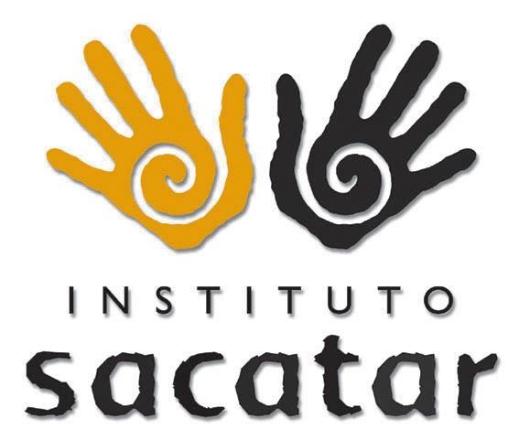

BIRTHDATE BIRTHPLACE

NEAREST INTERNATIONAL AIRPORT TO CURRENT RESIDENCE
CHECKLIST OF MATERIALS TO BE SUBMITTED WITH THIS APPLICATION (as specified in the Application Process)

□ Completed application form
□ Professional resumé
□ Description of the project
□ Description of the work needs
□ Work Samples
□ Technical Description of Work Samples

The residency will take place from 6 May to 1 July 2013

All application materials including this form must be
sent to

unesco-aschberg@sacatar.org

no later than Monday, 15 October 2012 at midnight in Brasília.

WHY BAHIA? (Explain, in 50 words or less, why you are applying to Sacatar and not some other program)

WHAT LANGUAGES DO YOU SPEAK?

PROVIDE TWO PROFESSIONAL REFERENCES WHO CAN COMMUNICATE IN ENGLISH OR PORTUGUESE:
NAME JOB TITLE E-MAIL TELEPHONE NUMBER

- | | |

- | | |

I Acknowledge that: Although the Instituto Sacatar takes great care in handling the documentation submitted, it cannot be held responsible for any loss or damage. I understand and agree to the conditions offered by the Instituto Sacatar as described on its website and in the download of the Resident´s Manual available at www.sacatar.org.

Signature Date

